**Mohamed Ahmed**

**Data Bootcamp – Just IT**

**03-10-23**

Data Visualisation



**Assignment 1**

Contents

**Policies and Procedures** 2

**Data Security:** 2

**Data Ownership:** 3

**Data Quality:** 3

**Data Retention:** 3

**Informed Consent:** 3

**Data Sharing:** 3

**Conclusion** 3

**Excel** 4

**GDP by year 2019** 4

**GDP (Gross domestic product)** 5

**Macros Buttons** 6

7

**Tableau** 7

**Top 10 Countries By GDP** 7

**Total GDP for All Countries** 8

**GDP By Year 2019** 9

**Top 5 Countries by Life expectancy At Birth** 10

**Top 5 Countries by Smartphone Users** 11

**Dashboard** 12

**Link to Tableau** 13

**Reflection** 14

# **Policies and Procedures**

As a data analyst working with data involves adhering to various policies and rules to ensure the ethical, legal, and responsible handling of data. These rules and policies are crucial for several reasons:

## **Data Security:**

Set encryption, access controls, and secure data storage to protect against unauthorized access or breaches. It is very important to take care of data security as data breaches can lead to reputational damage, financial losses, and legal liabilities.

## **Data Ownership:**

Make sure you define who owns the data and who has the right to use it. If the you don’t know who owns the data this can lead to conflicts and misuse of data.

## **Data Quality:**

Ensure data accuracy, completeness, and consistency by following data cleaning and validation processes. Inaccurate or incomplete data can lead to incorrect conclusions and poor decision-making.

## **Data Retention:**

Prior to working with data define how long data should be retained and when it should be securely deleted. It is very important to know that Keeping data longer than necessary can pose privacy risks and increase storage costs.

## **Informed Consent:**

Ensure that you get consent from individuals when collecting their data, and let them know about the purpose and scope of data usage. it is often a legal requirement to obtain consent as it is a fundamental ethical principle when dealing with data especially with confidential data.

## **Data Sharing:**

Conform to rules regarding sharing data with third parties. Unauthorized data sharing can lead to data breaches and privacy violations.

## **Conclusion**

This a brief overview of rules and policies when dealing with data as data analyst . It is essential for maintaining the integrity of data analysis, protecting individual privacy, conforming with the law, and preserving trust in data-driven decision-making processes. Violations can have serious legal, financial, and ethical consequences for both data analysts and the organizations you work for.

# **Excel**

## **GDP by year 2019**

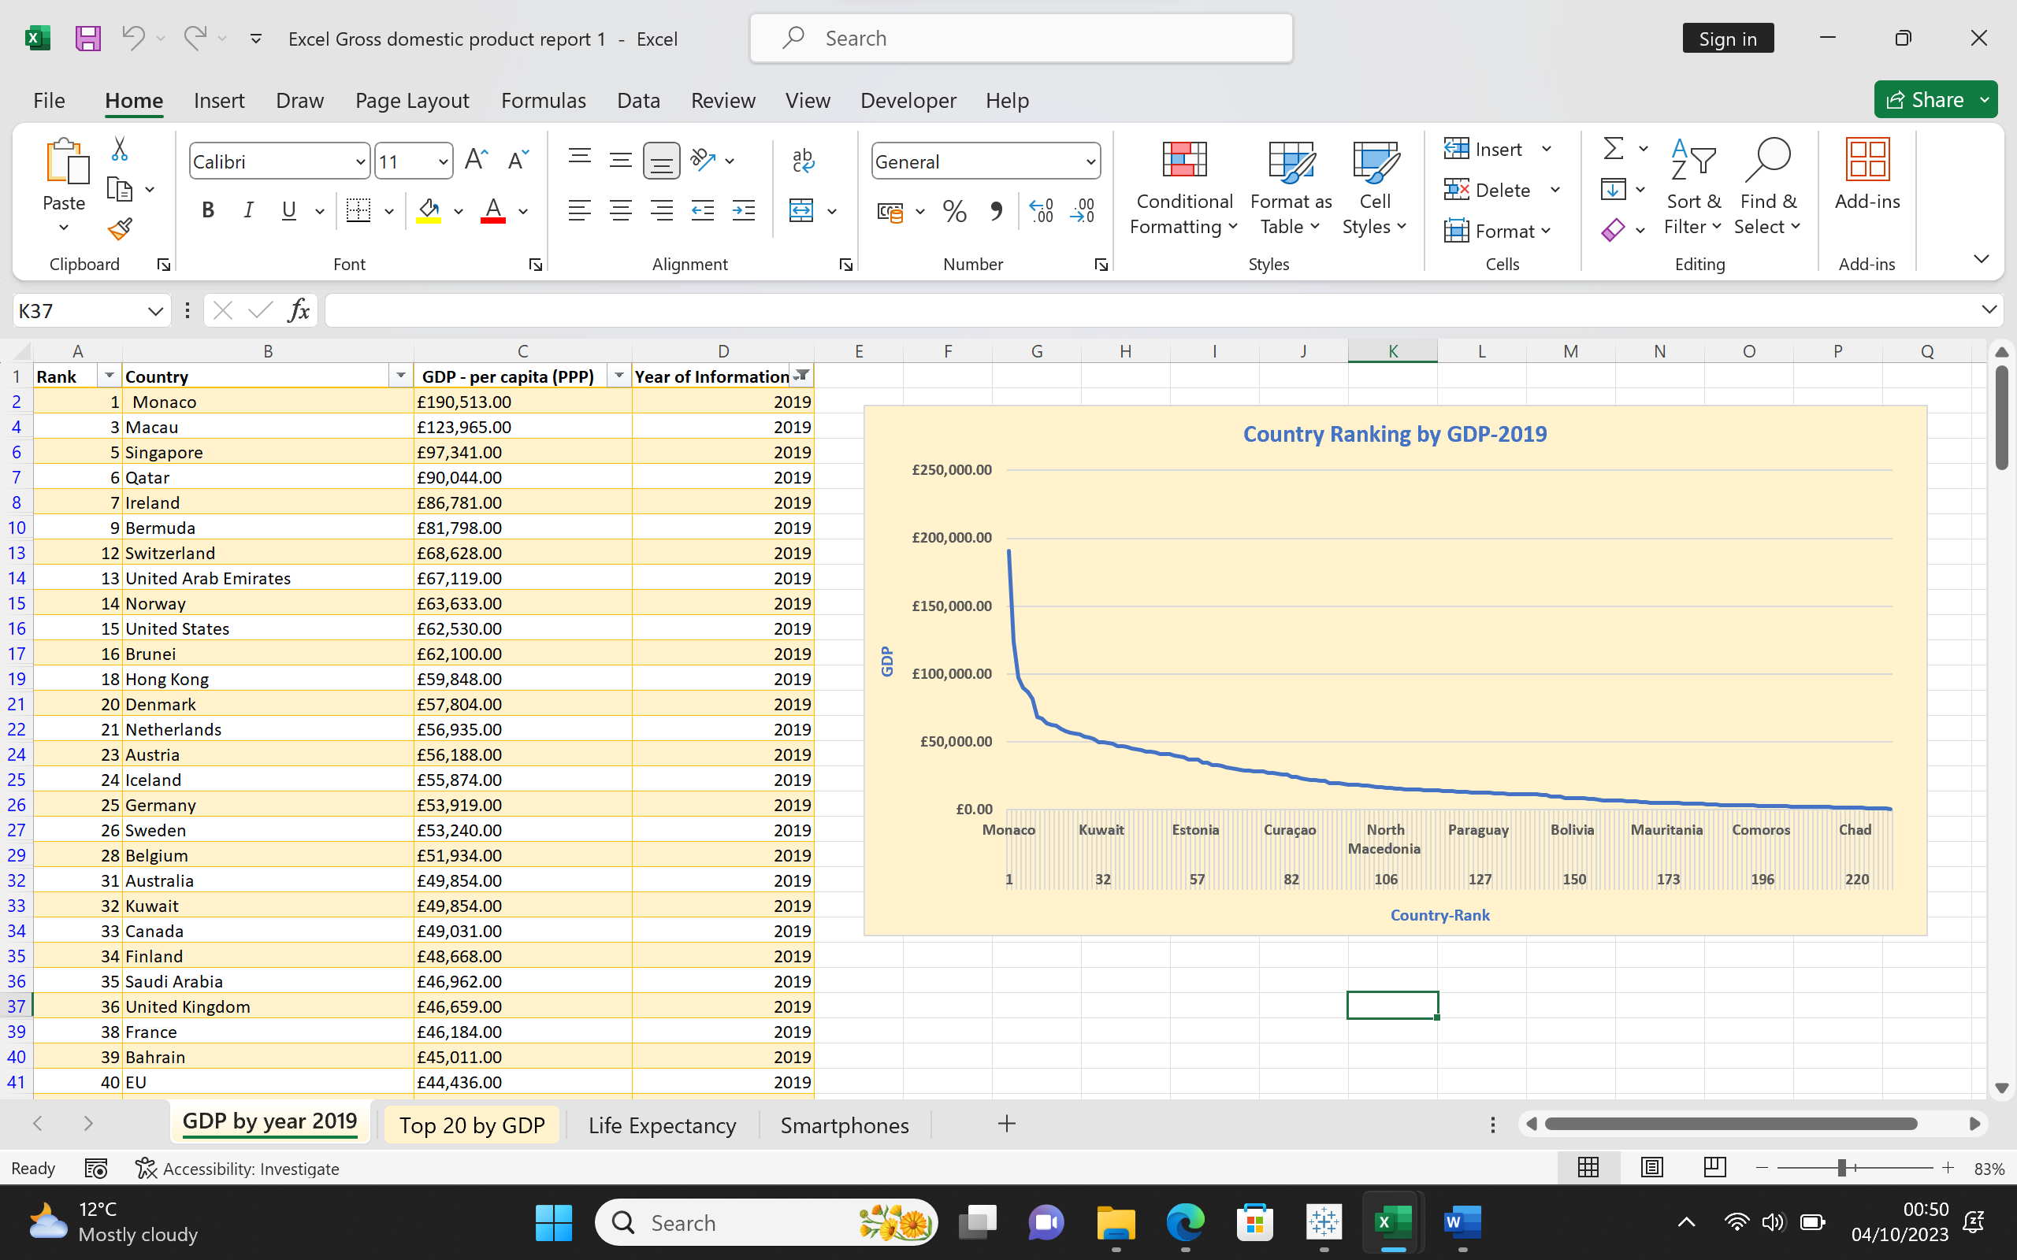

## **GDP (Gross domestic product)**

|  |  |  |  |
| --- | --- | --- | --- |
| **Rank** | **Country** | **GDP - per capita (PPP)** | **Year of Information** |
| 1 | Monaco | £190,513.00 | 2019 |
| 3 | Macau | £123,965.00 | 2019 |
| 5 | Singapore | £97,341.00 | 2019 |
| 6 | Qatar | £90,044.00 | 2019 |
| 7 | Ireland | £86,781.00 | 2019 |
| 9 | Bermuda | £81,798.00 | 2019 |
| 12 | Switzerland | £68,628.00 | 2019 |
| 13 | United Arab Emirates | £67,119.00 | 2019 |
| 14 | Norway | £63,633.00 | 2019 |
| 15 | United States | £62,530.00 | 2019 |
| 16 | Brunei | £62,100.00 | 2019 |
| 18 | Hong Kong | £59,848.00 | 2019 |
| 20 | Denmark | £57,804.00 | 2019 |
| |  | | --- | |  | |  |  |  |
|  |  |  |  |
|  |  |  |  |
|  |  |  |  |
|  |  |  |  |
|  |  |  |  |
|  |  |  |  |
|  |  |  |  |
|  |  |  |  |
|  |  |  |  |
|  |  |  |  |
|  |  |  |  |
|  |  |  |  |
|  |  |  |  |
|  |  |  |  |
|  |  |  |  |
|  |  |  |  |
|  |  |  |  |

## **Macros Buttons**

# 

# **Tableau**

## **Top 10 Countries By GDP**

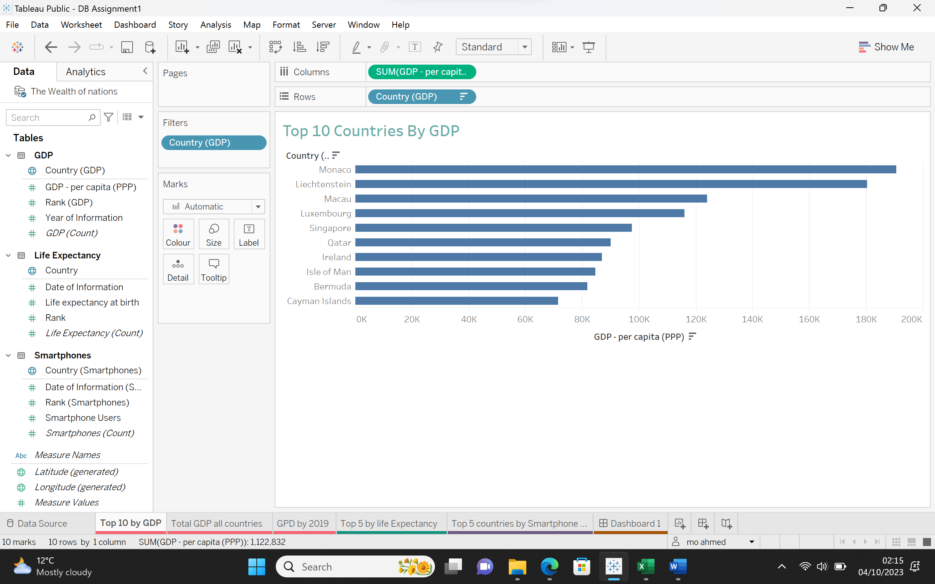

## **Total GDP for All Countries**

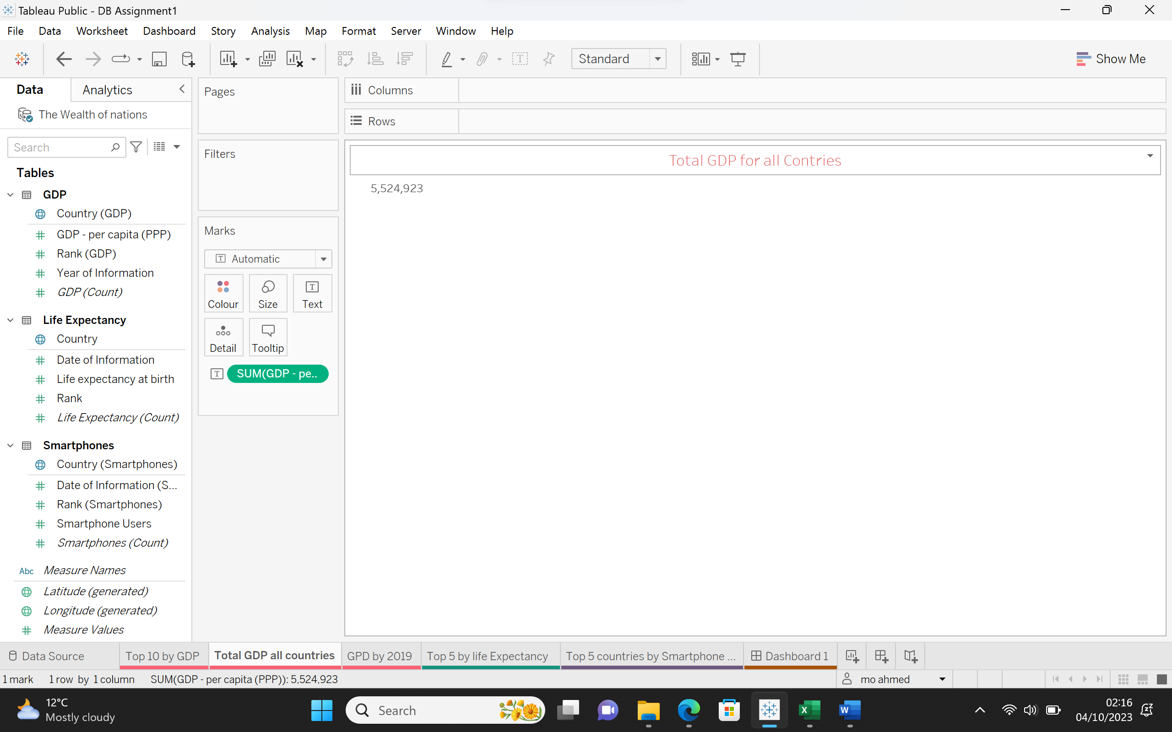

## **GDP By Year 2019**

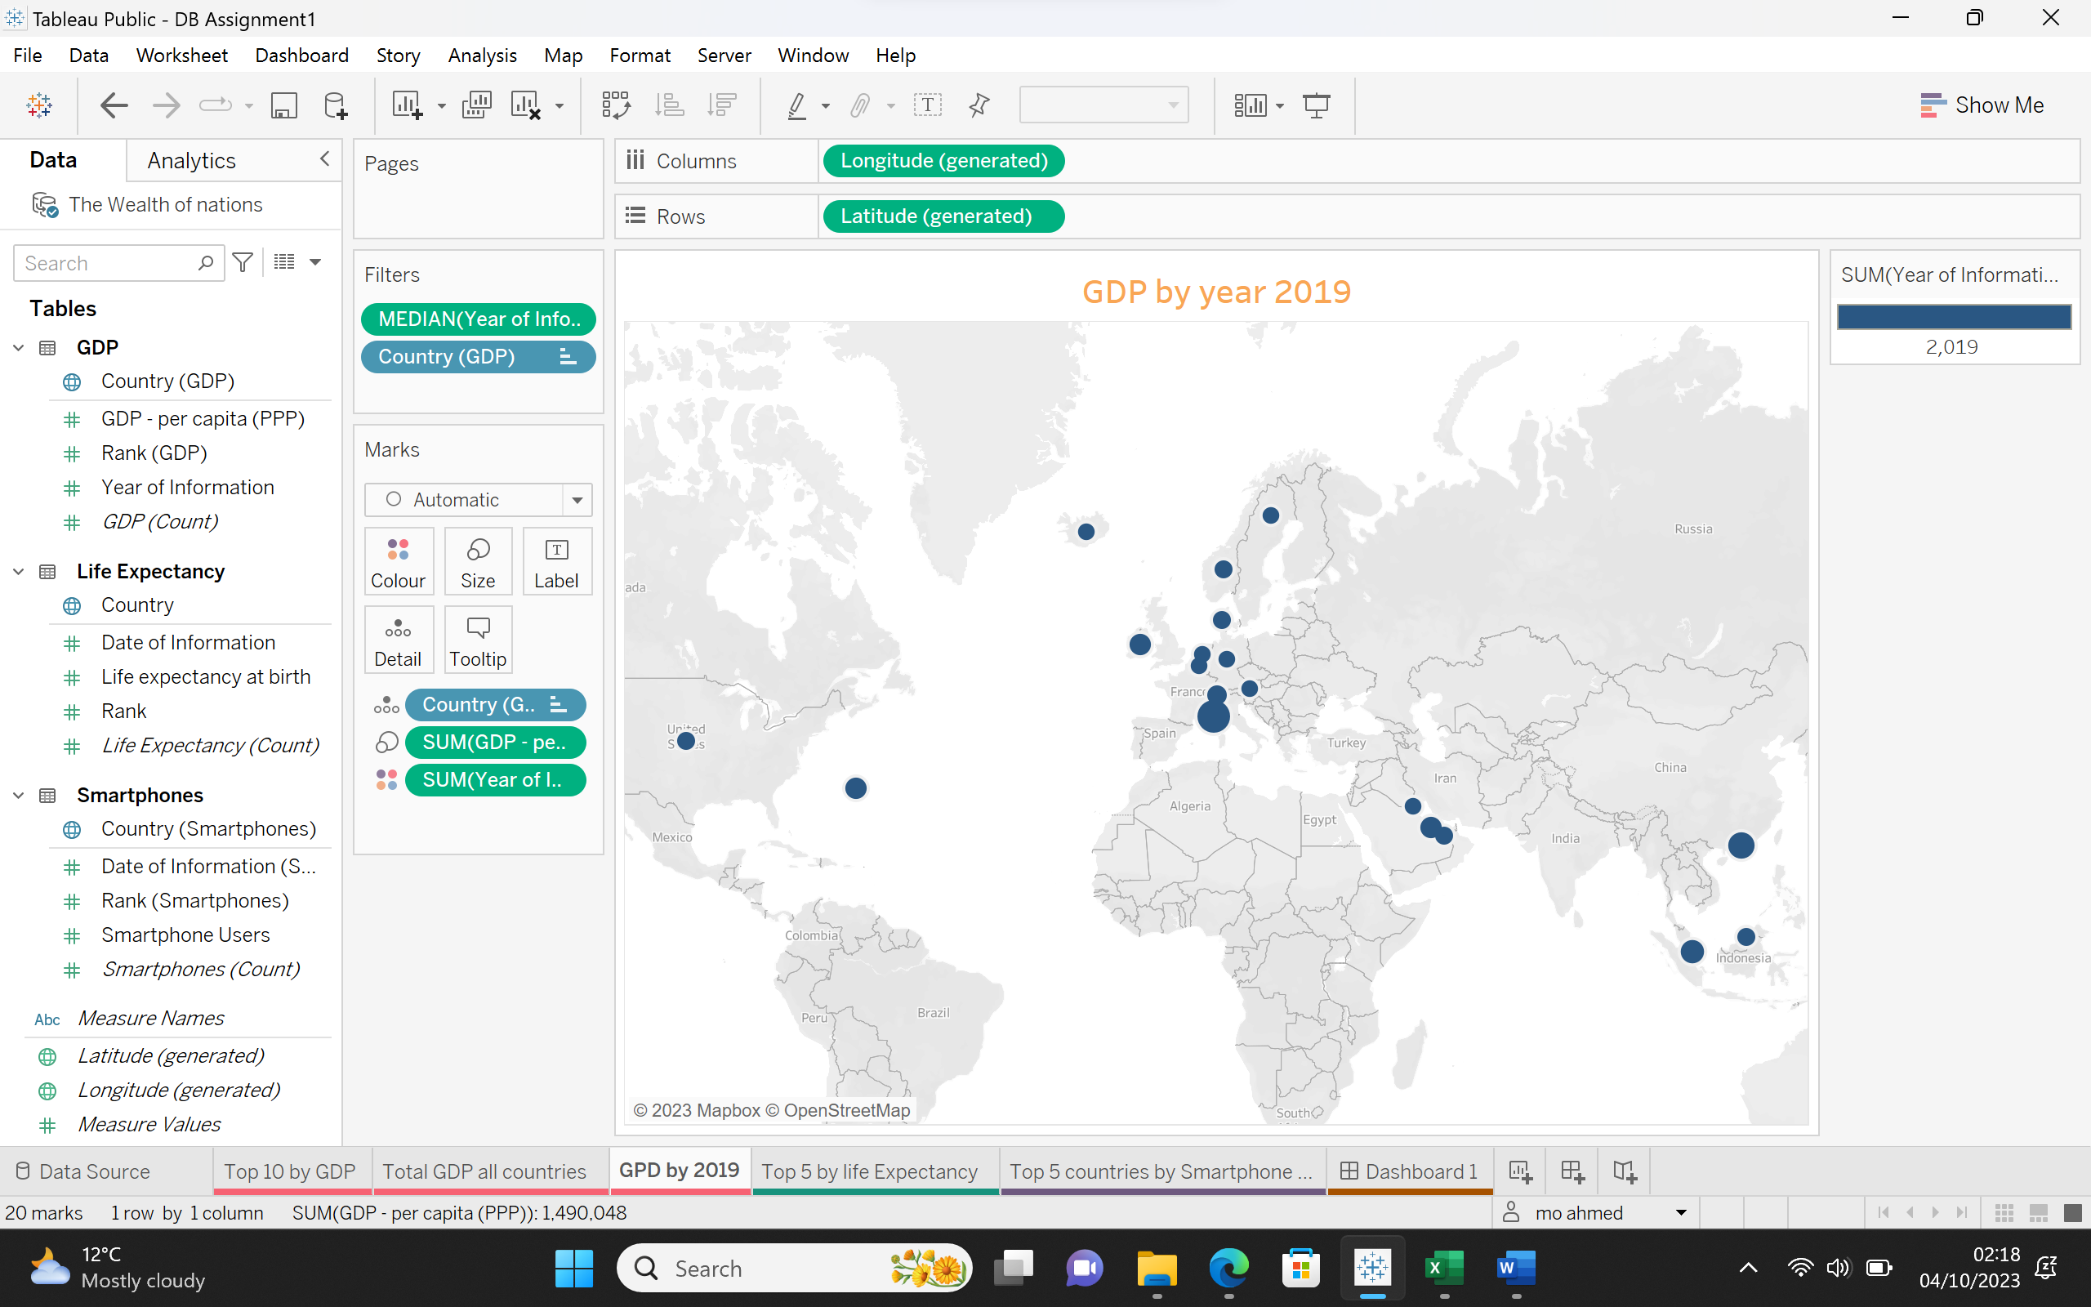

## **Top 5 Countries by Life expectancy At Birth**

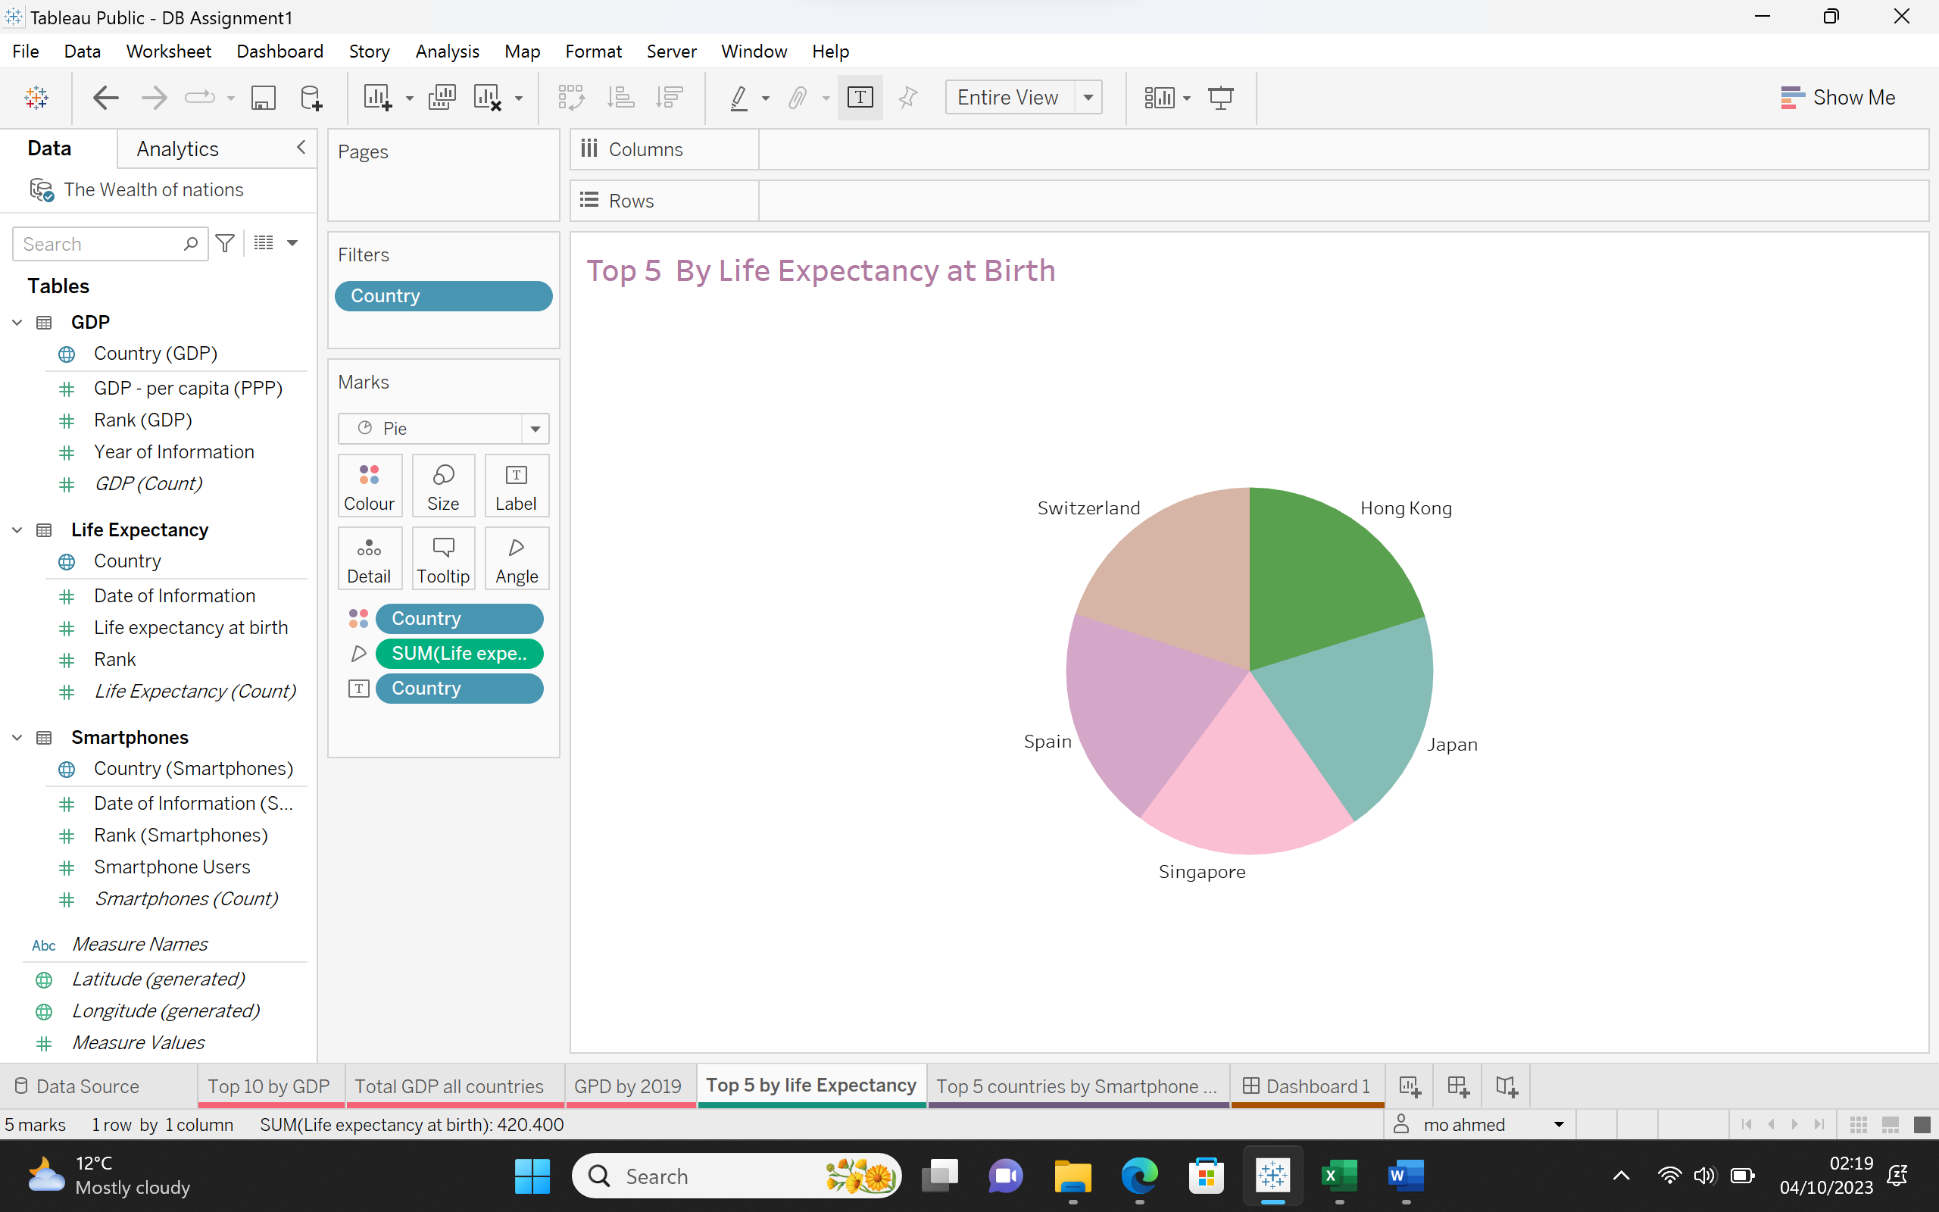

## **Top 5 Countries by Smartphone Users**

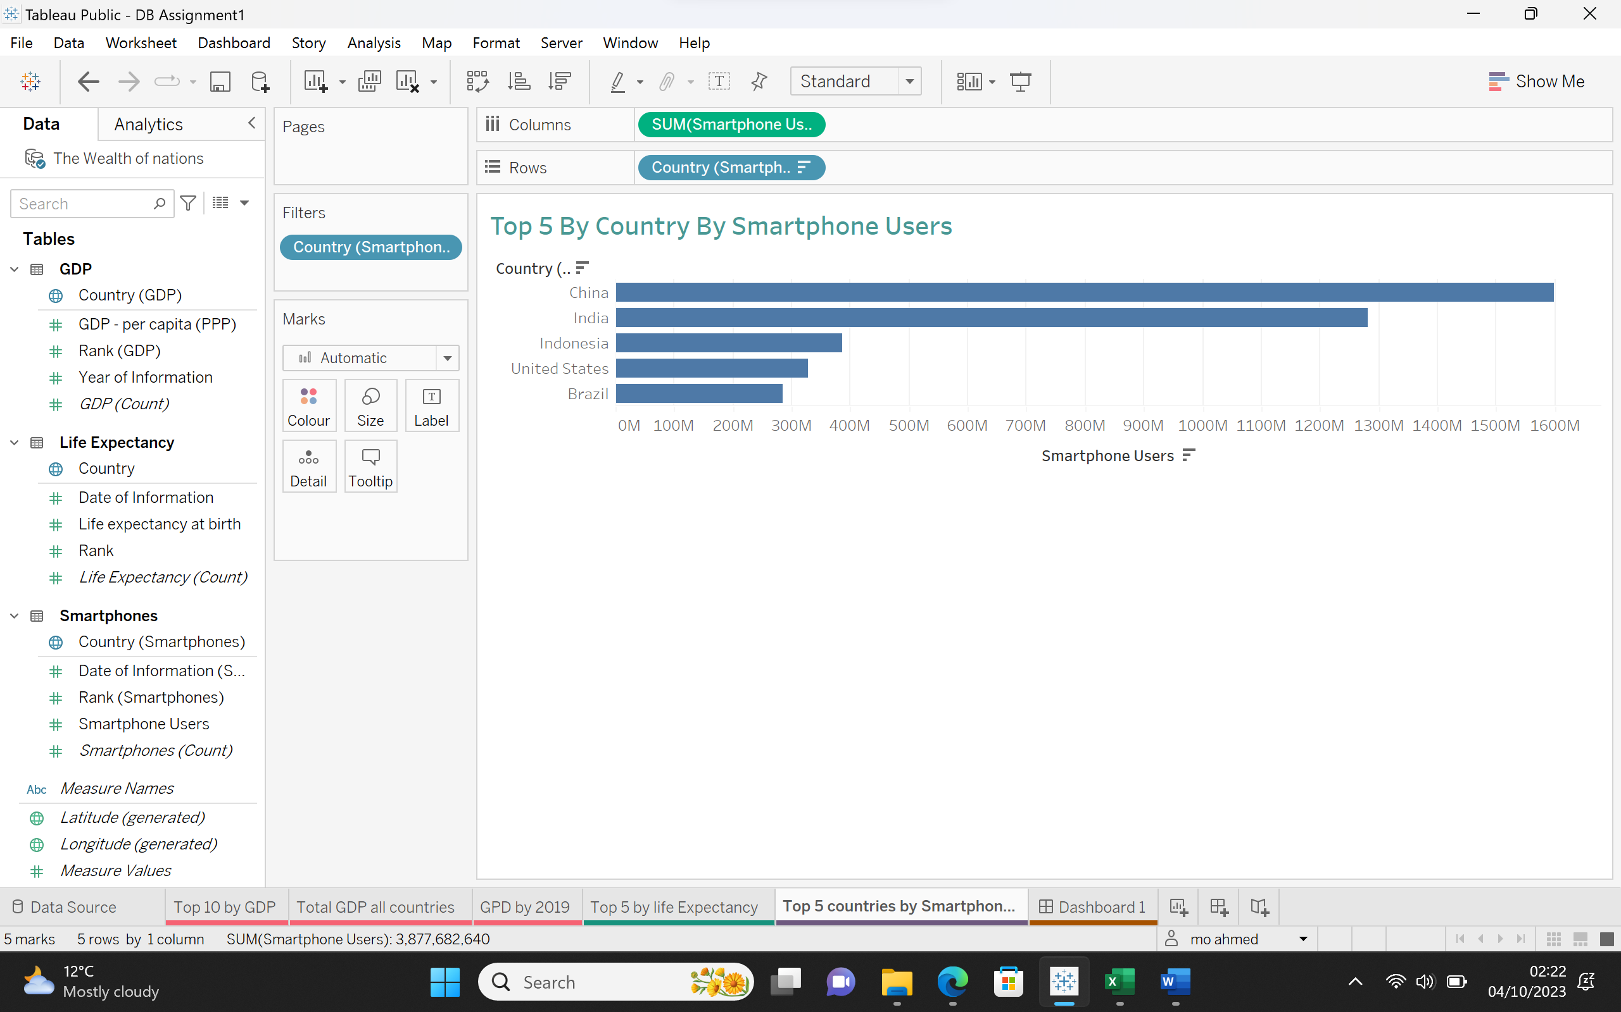

## **Dashboard**

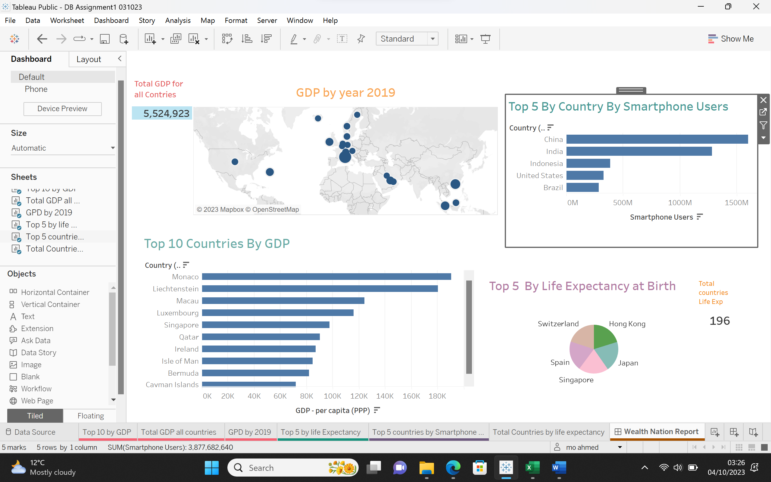

## **Link to Tableau**

[DB Assignment1 031023 | Tableau Public](https://public.tableau.com/app/profile/mo.ahmed/viz/DBAssignment1031023/WealthNationReport?publish=yes)

# **Reflection**

I found the assignment very helpful for practicing what I have learned over the past few weeks. I have acquired new tools and enhanced my existing skills, especially in Excel. In the Excel tasks, the challenge for me was recording the macro for printing. I tried different methods to create the macro, but when it came to running it, I encountered difficulties, and it didn't work for me. Fortunately, after researching on the internet, I managed to create it. I don't know exactly what the issue was; it could have been a software problem or maybe the printer was not connected to my laptop. The print macro worked fine when printing/saving to a PDF file, but it was challenging to create when using the printer device. Consequently, I decided to create a macro for print preview.

In the first Excel task, protecting the Excel file with a password, it wasn't very clear, and I was confused about whether to set up a password on the Excel file and encrypt it or just protect the structure of the workbook with a password. Eventually, after speaking with a colleague, I decided to protect the structure of the workbook.

Regarding the Tableau task, I struggled to filter the GDP sheet to display only the data for the year 2019. Additionally, I was a bit confused when importing the data sheets into Tableau, as I couldn't figure out the relationships between them, as the data for countries differed from one sheet to another. The GDP sheet had 228 entries, the Life Expectancy sheet had 196, and the Smartphones sheet had 74. I also had difficulty creating a calculated field; it was challenging for me to determine the correct calculations between the fields. It would have been better if the assignment tasks in Tableau were identified similarly to the Excel tasks.

Overall, I had the opportunity to test myself and practice more. In conclusion, I can say that I need to work more on Tableau to become more confident in using it comfortably.